R Worksheet #1

R data types (scalars, vectors, lists, data frames), vector/matrix algebra, basic plots and graphs

Dr. Scott

CSI 500

Spring 2019

# Problem #1: R Data types

In the lectures, we discussed various built-in R data types. For this exercise, we will focus on vectors. Use your R skills to accomplish the following.

Imagine you own a portfolio consisting of shares of the following high technology companies as shown in Table 1. Recent closing prices for these shares of stock are shown in the 3rd column of the table.

Table 1. Stock Portfolio

|  |  |  |
| --- | --- | --- |
| **Company** | **Number of Shares** | **Closing Price ($)** |
| Hewlett-Packard | 1000 | 18.79 |
| IBM | 350 | 160.26 |
| Google | 250 | 1134.42 |
| Amazon | 500 | 1571.68 |

* Write an R expression to store the names of the companies as a character vector
* Write an R expression to store the number of shares as a numeric vector
* Write an R expression to store the closing price as a numeric vector
* Write an R expression using your vectors and R vector arithmetic operator(s) to compute your total portfolio value (number of shares * closing price). What is the market value of your portfolio?

Assume you want to go on a vacation after the Spring semester, and you need to book travel and hotel fares now before summer travel rates go up. You decide to sell 100 shares of IBM stock and 50 shares of Google stock to finance your vacation.

* Write an R expression to indicate the change in number of shares (hint: you may use negative numbers and add the change vector to your original vector).
* How much is the current value of your portfolio after you make the sale?
* How much money do you now have for your vacation (ignore taxes and brokerage fees for this example).

Now assume that Congress passes the "High Technology Investment Act of 2018", which provides tax benefits and incentives for high tech companies. As a result of this new law, high tech companies are expected to see stock prices rise 6.25%.

* Write an R expression that will adjust the value of your stock portfolio as a result of this legislation
* How much is the new value of your portfolio after the law takes effect and stock prices go up?

# Problem #2: Microeconomics and Matrix methods

In the lectures, we discussed various mathematical operations available for vectors and matrixes in R, and covered an example of using matrixes to solve a system of linear equations. Use your R skills to accomplish the following. Note: this exercise may be challenging!

Imagine you are a market analyst, and you are assigned the task of forecasting sales price and demand for a new type of athletic wristwatch called the ZipFit. Based on analysis of similar products in this market space, you estimate that for production of about 1 million units, the market price could be about $500, but ZipFits could sell for less if there were higher levels of production. Use the graph in Figure 1 as a guide for this problem.

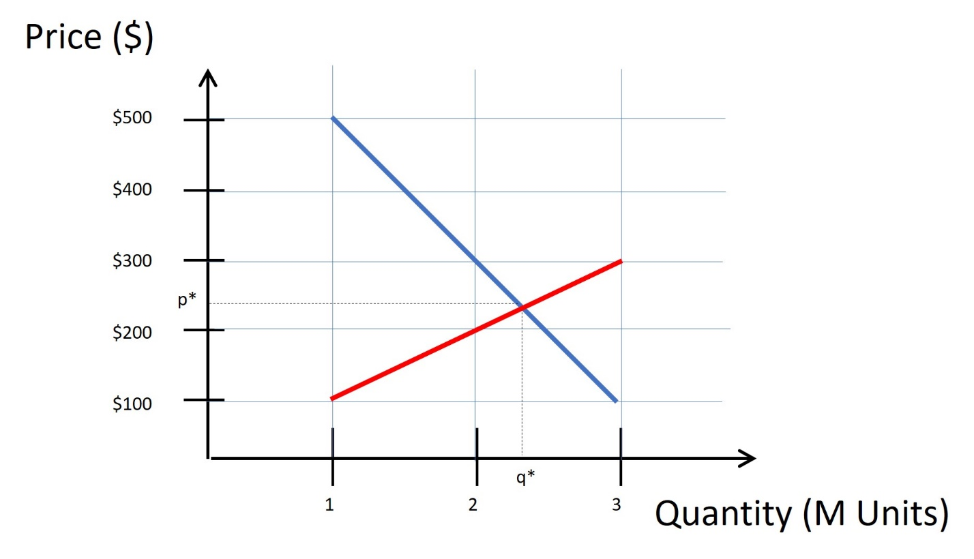

Figure 1. Production and Consumption of ZipFits

* What is the slope (m) of the demand curve (the blue line)? Recall that slope is defined as dy/dx, or (y2-y1)/(x2-x1).
* What is the Y-intercept (b) of the demand curve (the blue line)
* Using the values you just found, what is an expression for the line expressing the demand curve, using *Y = mx + b* format?
* What is the slope (m) of the supply curve (the red line)? Recall that slope is defined as dy/dx, or (y2-y1)/(x2-x1).
* What is the Y-intercept (b) of the supply curve (the red line)?
* Using the values you just found, what is an expression for the demand curve using *Y = mx + b* notation?

Use linear algebra to transform these two equations into a system of vector/matrix form, as follows. Notation in blue font corresponds to demand function, and notation in red font corresponds to supply function.

y = mx + b

y = mx + b

-mx + y = b

-mx + y = b

* After following through the above algebra, write an R expression for the matrix A that contains the supply and demand slope values m. Use the matrix() function, with nrow=2, ncol=2, byrow=TRUE, and specify your computed data for the supply and demand m values.
* Using R matrix function "solve()" to compute the inverse of the matrix A. What is your computed inverse matrix A-1 ?

Using your computed inverse matrix A-1, now solve the matrix expression below to compute the values for x and y. Recall that any matrix A multiplied by its inverse A-1 results in the identity matrix I.

* What is the R expression using a vector and a matrix to compute b*A-1 ?
* What is the optimal value x for the quantity of ZipFits to be produced (q*) in this market system?
* What is the optimal value y for the price of ZipFits to be consumed (p*) in this market system?

# Problem #3: Basic Plots and Graphs

In the lectures, we discussed how to make basic R plots and graphs. Use your R skills to accomplish the following.

* Create a sample data set called data_one using rnorm( 100, mean=0.0, sd=1.0)
* Create a sample data set called data_two using rnorm( 100, mean=0.8, sd=2.5)
* Create a stem-and-leaf plot for data_one
* Create a histogram for data_two
* Create a scatter plot for data_one
* Create a 2-D line plot showing the sorted values for data_two
* Create a double boxplot for data_one and data_two. Use this command syntax:
* boxplot( data_one, data_two)